January 12th, 2021 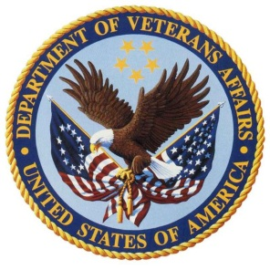

Dear Vendor,

The Veterans Benefits Administration has partnered with the Tungsten Network to provide electronic invoicing services, free of charge, to our vendor community. To deliver the best possible customer service, we have modernized our invoice payment system to meet the Federal Government OMB electronic invoicing mandate.

Tungsten Network offers simple and secure solutions in compliance with the Prompt Payment Act and IPERA to quickly and accurately receive your payments while also eliminating improper payments. The benefits of e-Invoicing the VA using the Tungsten Network include:

* **Instant Invoice Validation** 🡪 Get notified of errors before you send your invoice, resulting in fewer invoice exceptions.
* **Expedited Payments Processing** 🡪 No more manual checking means we can quickly process your payments in accordance with the Prompt Payment Act.
* **Real-Time Status** 🡪 Track the status of your invoice to see when you will get paid, and if there’s an exception find out why and who to contact.
* **No installation of hardware or software required**
* **No Cost to You** 🡪 Tungsten Network electronic invoicing service includes data mapping, transaction fees, and invoice status post-delivery free of charge to VAFSC vendors.

**All vendors are requested to register for e-invoicing on the Tungsten Network by Feb 3rd, 2021.**

**What do you need to do next?**

Register your legal entity with Tungsten Network by visiting:

**www.tungsten-network.com/veteransaffairs**

Select the Web Form solution, the website will prompt you to follow the registration steps. Once registered, **search for The Veterans Affairs** buyer entity and request to connect directly on the portal.

Complete the registration by February 3rd, 2021 to avoid interruptions to your invoice processing and payment. If you have difficulties registering, please contact Tungsten Network Support at +1 (877) 489 6135

For additional questions regarding this transition, please email us at [VAFSCCSHD@va.gov](mailto:VAFSCCSHD@va.gov) or call us at 1-877-353-9791.

Thank you for your support during this transition.

Best Regards,

Dan O’Neil

